**Page Logic:**

Users can browse index page and view the detail of projects we represent on the homepage, but they cannot make comments, donate to the projects or rates the projects unless they have logged in.

Users should be able to sign up or log in on the index page and the project page. So we provided the user interface on the navigation bar.

Users should be able to start a new project or visit his or her personal page after they have logged in. So we provided the user interface on another navigation bar.

Users should have their personal home pages, where they can modify their profiles and display all kind of information about themselves.

Every project should be displayed on a project pages, users can modify their own project pages as well as visit the project pages created by the others.

**Specific page design and implement:**

**Index page**: Index page is prepared for both the guests and the users, we use a carousel design to display the most important information about our website, below which we provide three projects randomly recommended by us for users to explore.

**Navigation bar:**

Every page should have the navigation bar with UI consistency, but the user interface provided by the navigation bar could be different depending on the state of user: being login, being log out. So we extracted the code of navigation bar out as two independent file.

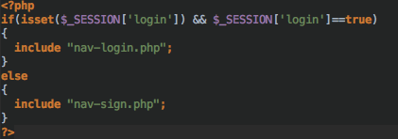

Code above is used to decided with navigation bar file should be included.

**Project page:**

Project page is one of the most important pages, which is prepared for both the guests and the users. However, the content could be different, for example, our users can make comments to that project, like the project, donate to the project and so on. But the guests can only browse the information about that project.

We achieved that by constructing the page dynamically, below is an example.

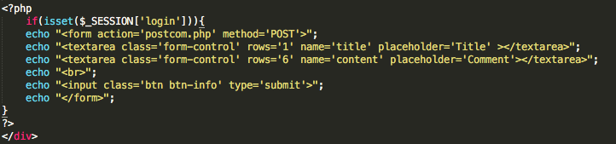

When the user have logged in, he or she will be able to make comments to the project, but if the guest have not logged in, the comments interface won’t be shown on the html page sent back to he or her.

**Usage:**

When a user visits my systor the first timeem f, he/she will see the main page as picture following:

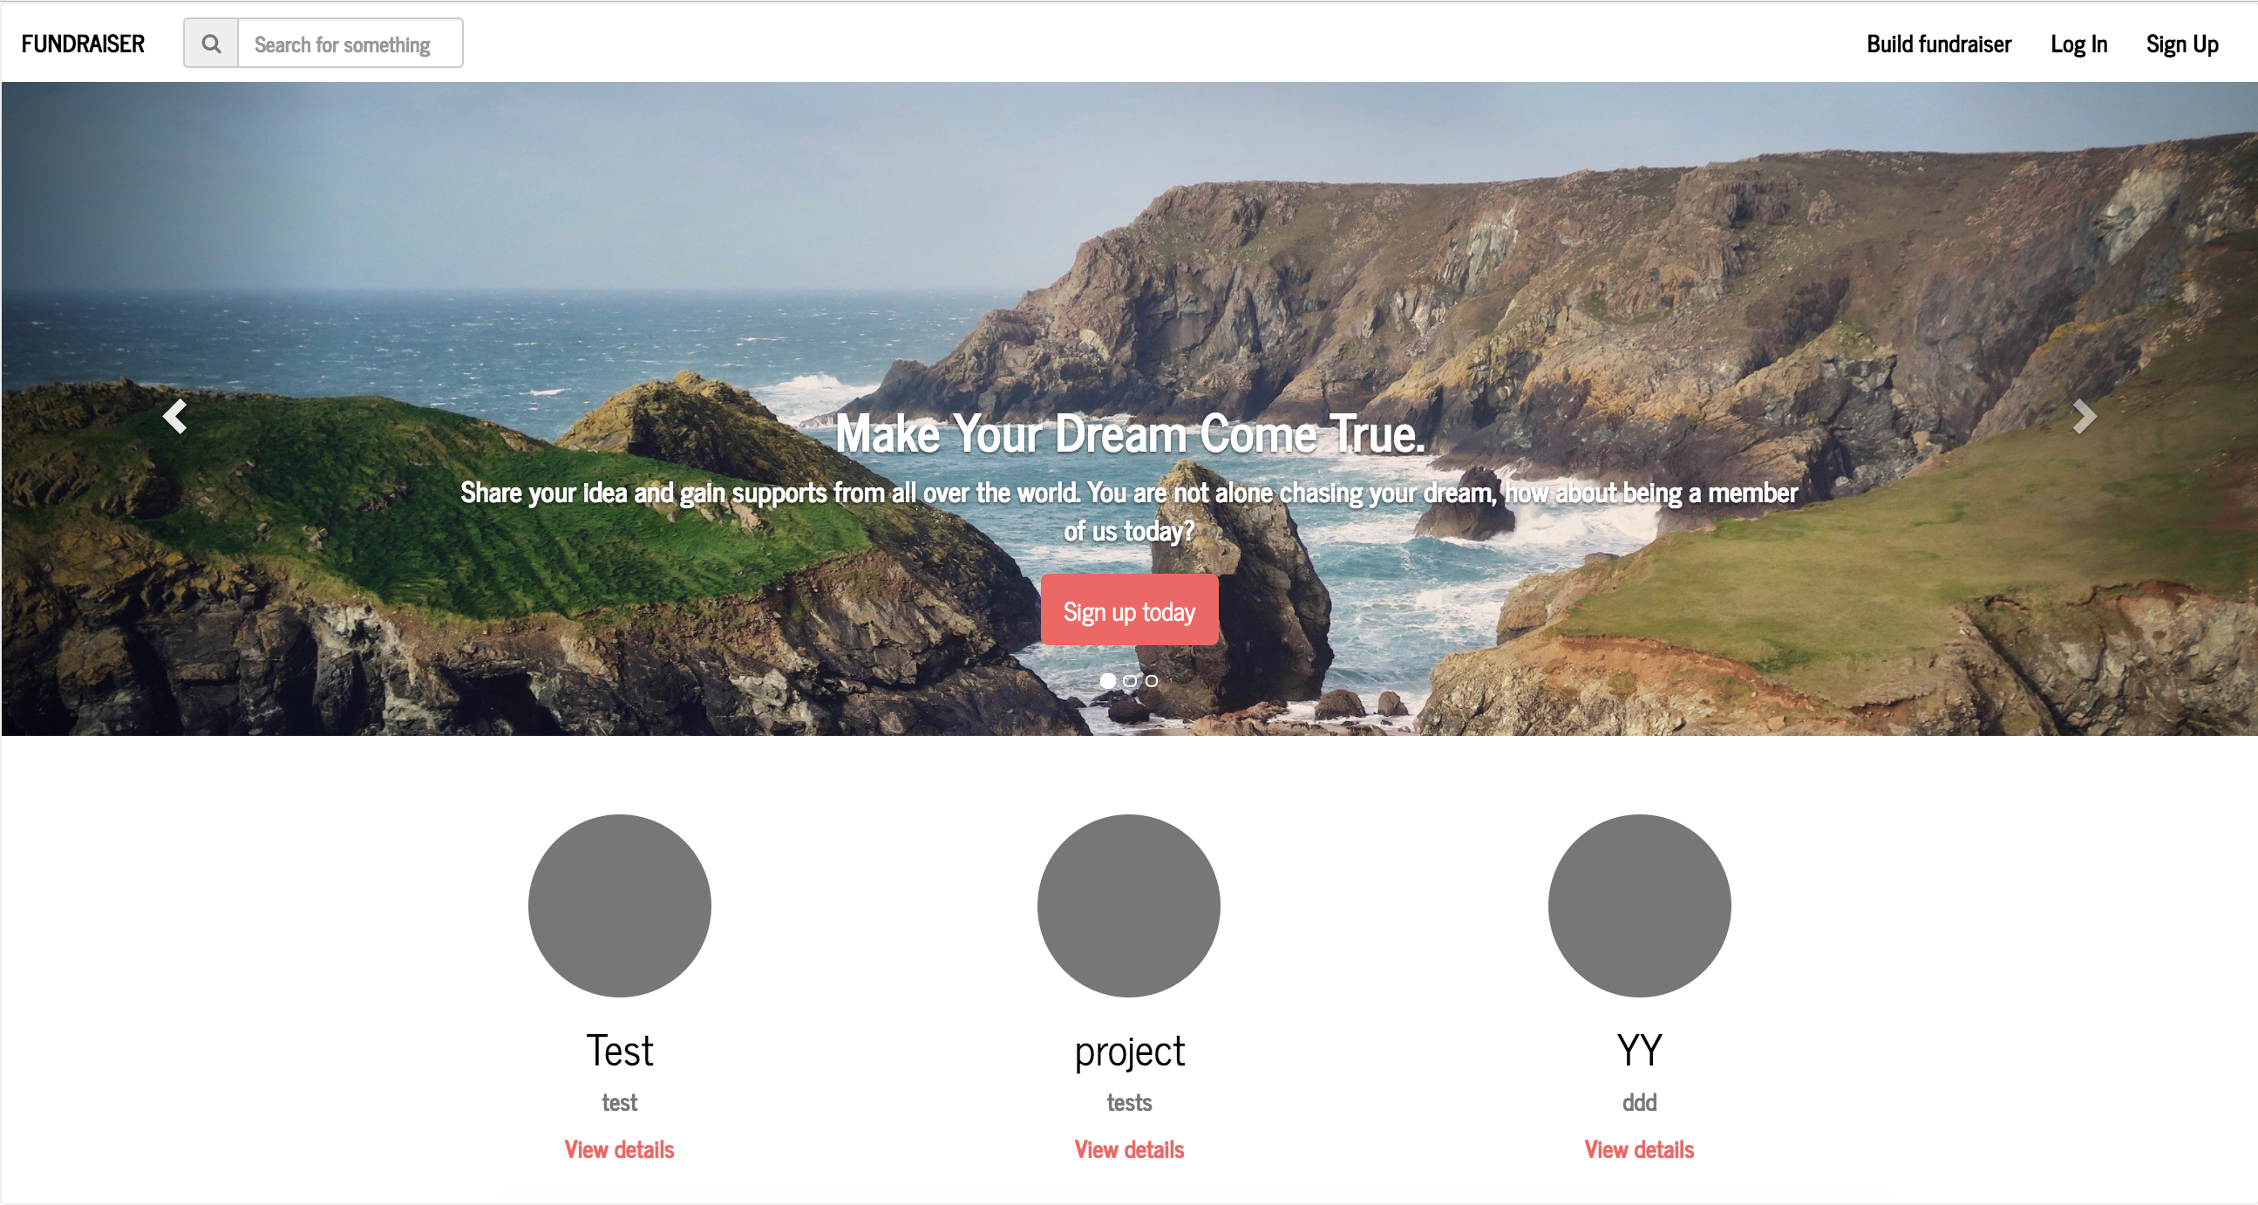

Basically, the main page has three parts from top to bottom.

First part is the navigation bar.

User can click ‘FUNDRAISER’ to return to this page at whichever page he/she is. He/she can search for projects by typing some key words he/she is interested in. For example, if he/she want to find out any projects concerns with ‘jazz’, he/she can type ‘jazz’ in search bar and the result will be like this:

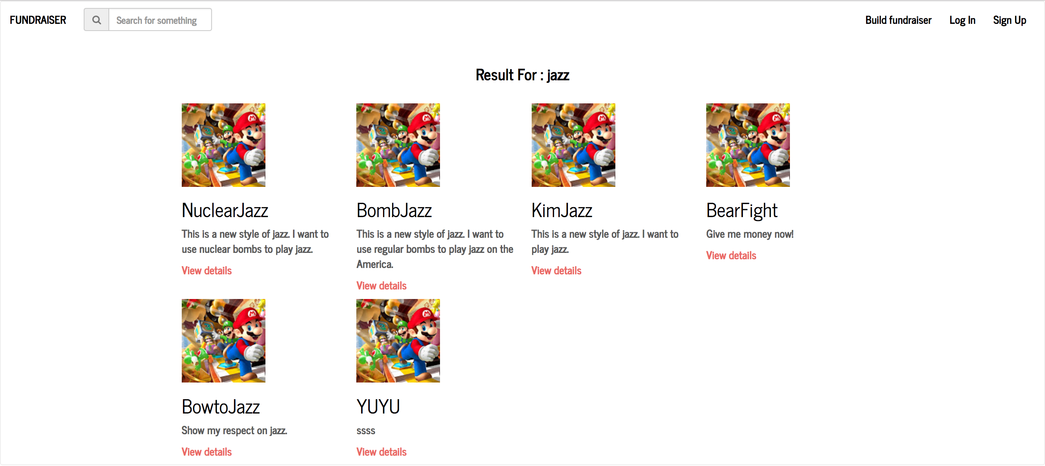

Any projects containing the string ‘jazz’ at their name or description or tags will show up because of search. By the way, if the user inputs nothing and search, all projects will show up. Since the user is a guest for now, he/she need to login or sign-up before he/she posts a project or donate. If he/she is guest and clicks ‘BUILD FUNDRAISER’, the page will be redirected to a login page.

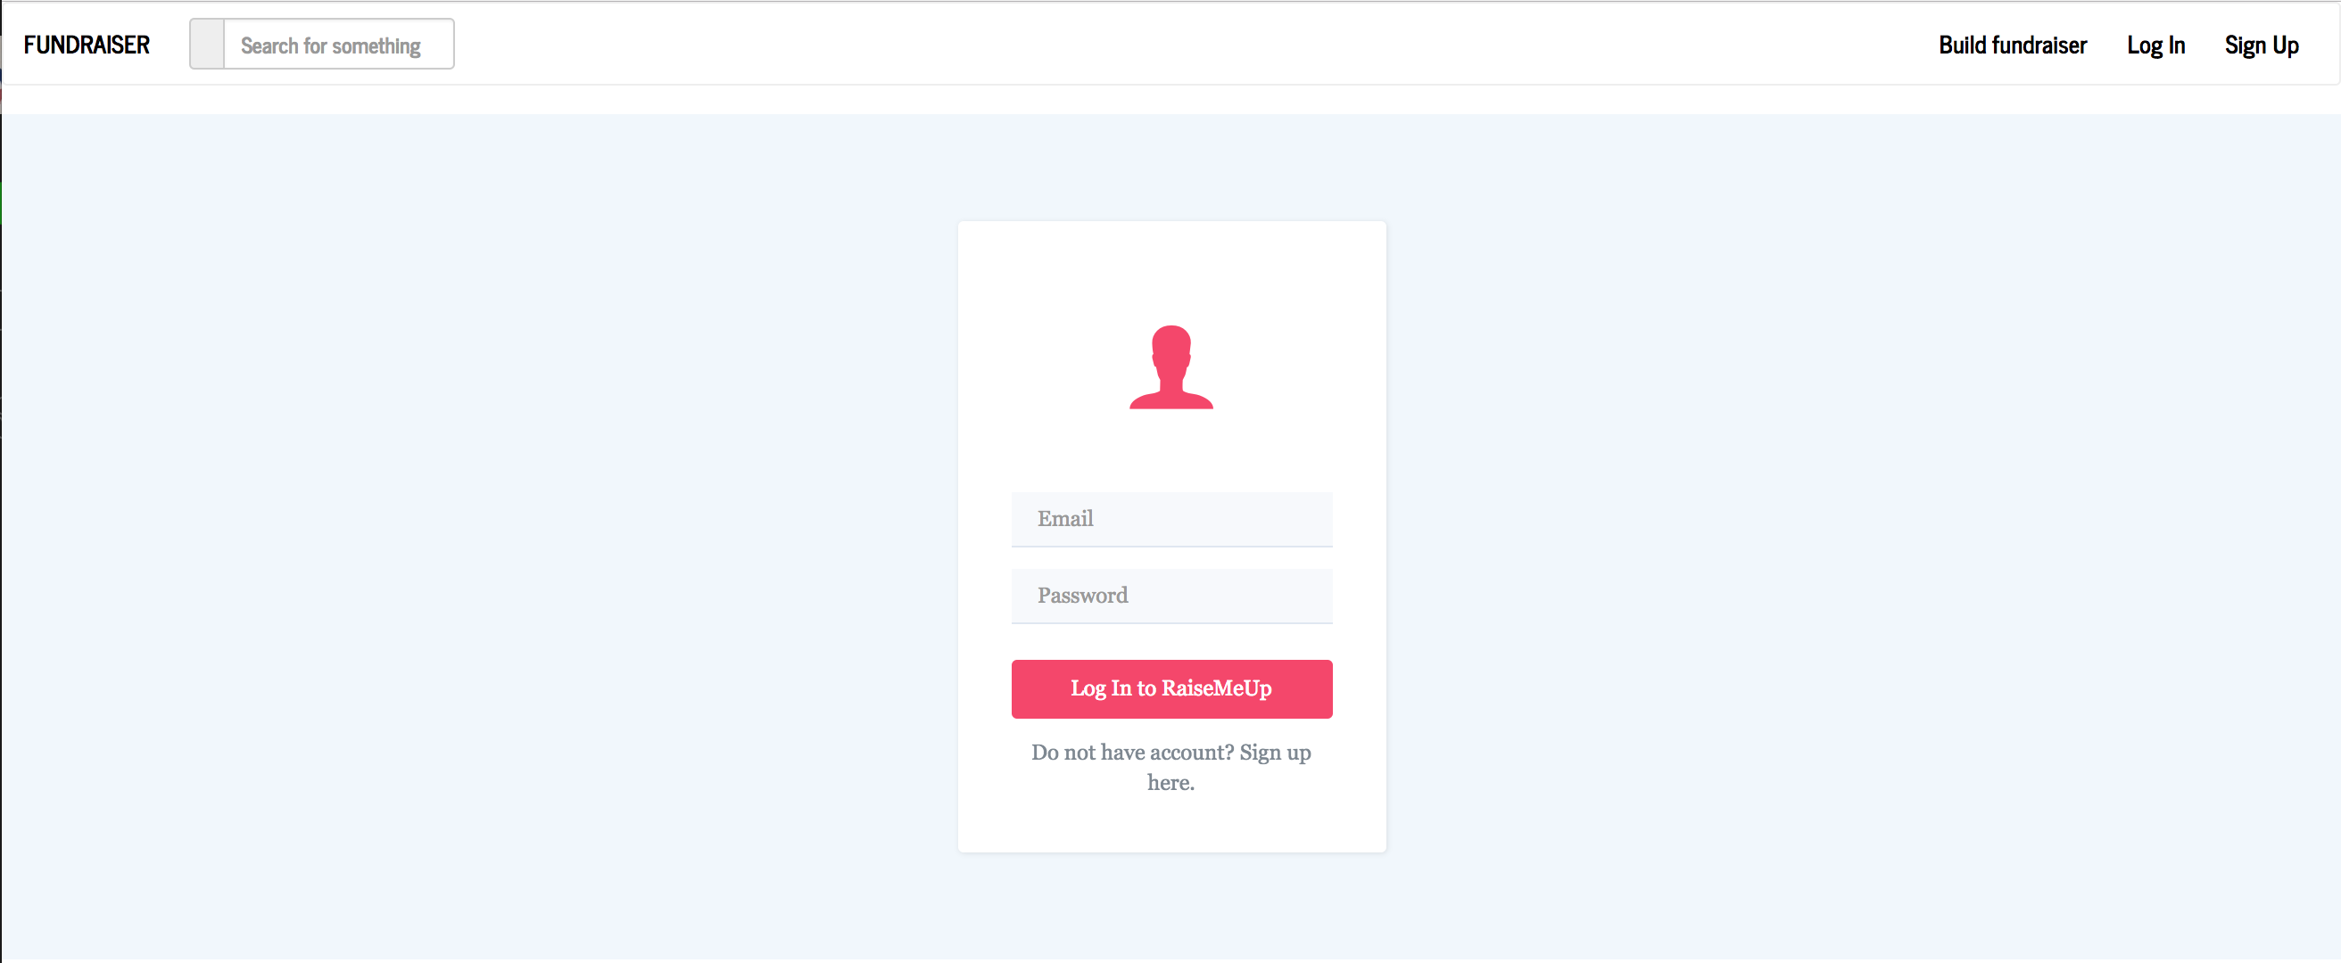

In this page, he/she can login in if an account is available or just sign up.

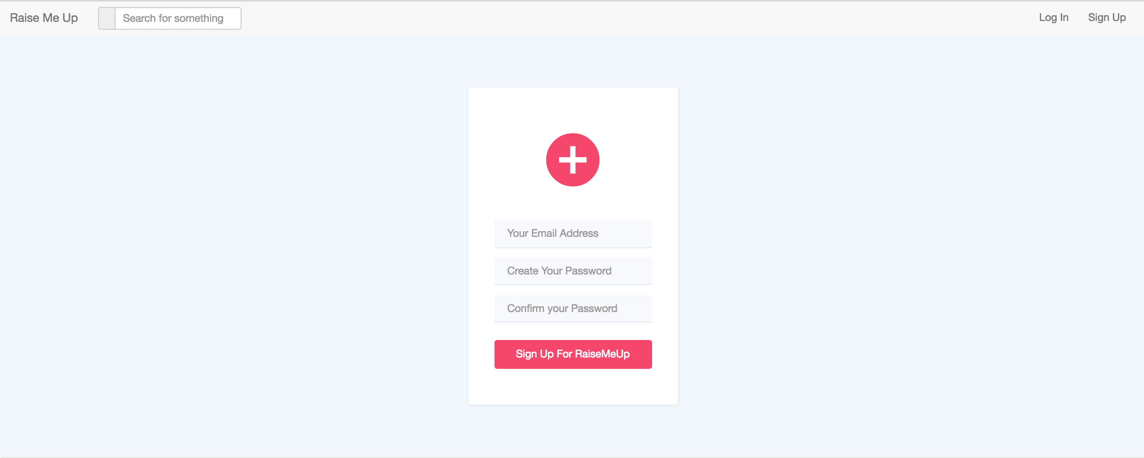

When he/she signs up, he/she needs to input the email and password to create an account. If the email is valid and never used at my system before and two passwords are same, the page will be redirected to another one to set username.

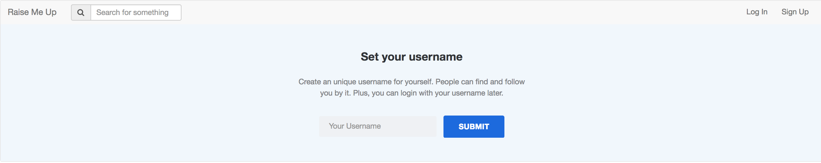

The username is set to be unique, so if the username isn’t occupied, the user will find out he/she is at main page again except for the change at the navigation bar.

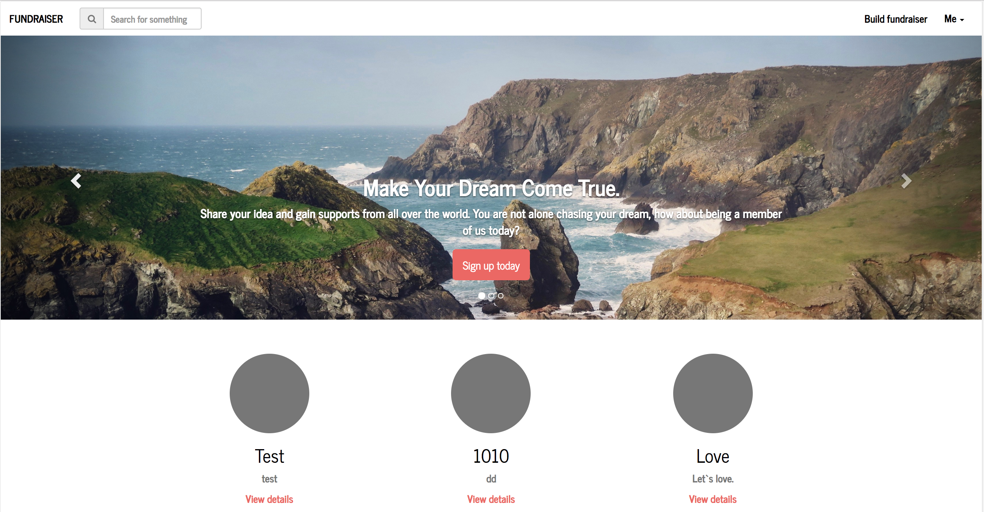

It is clear that no ‘login’ and ‘signup’ remain at nav-bar, the user can click ‘me’ to enter personal page or log out.

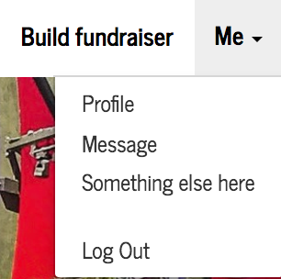

Everything is good for now. But if when the user inputs an email occupied already or mis-input password or just uses a username used by others, alert will turn out to tell the user what is going wrong.





Now, assuming the user has signed up or logged in successfully, he/she will be returned to the main page as said before.

The second part of the main page is combined with three big picture.

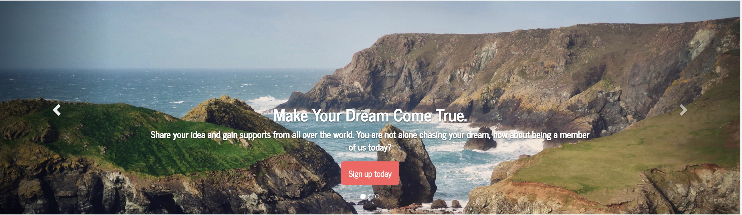

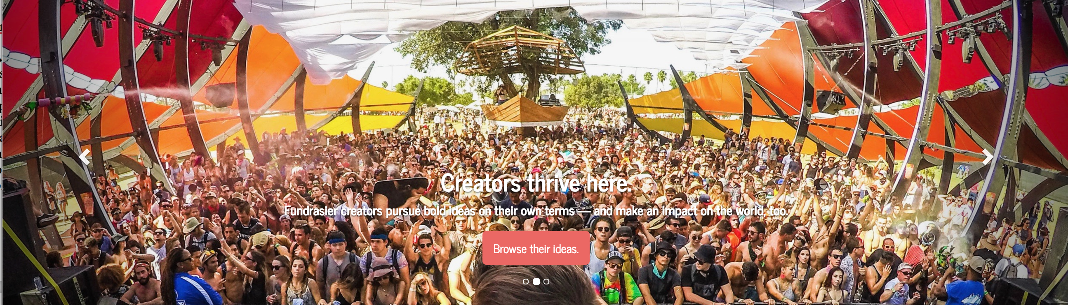



First one contains a link to sign-up page. The second one contains a link to show all projects in my system. And the third one contains info about my partner and me.

The third part of the main page is three projects randomly fetched from database.



By clicking the ‘VIEW DETAILS’, the user can enter in a project page.

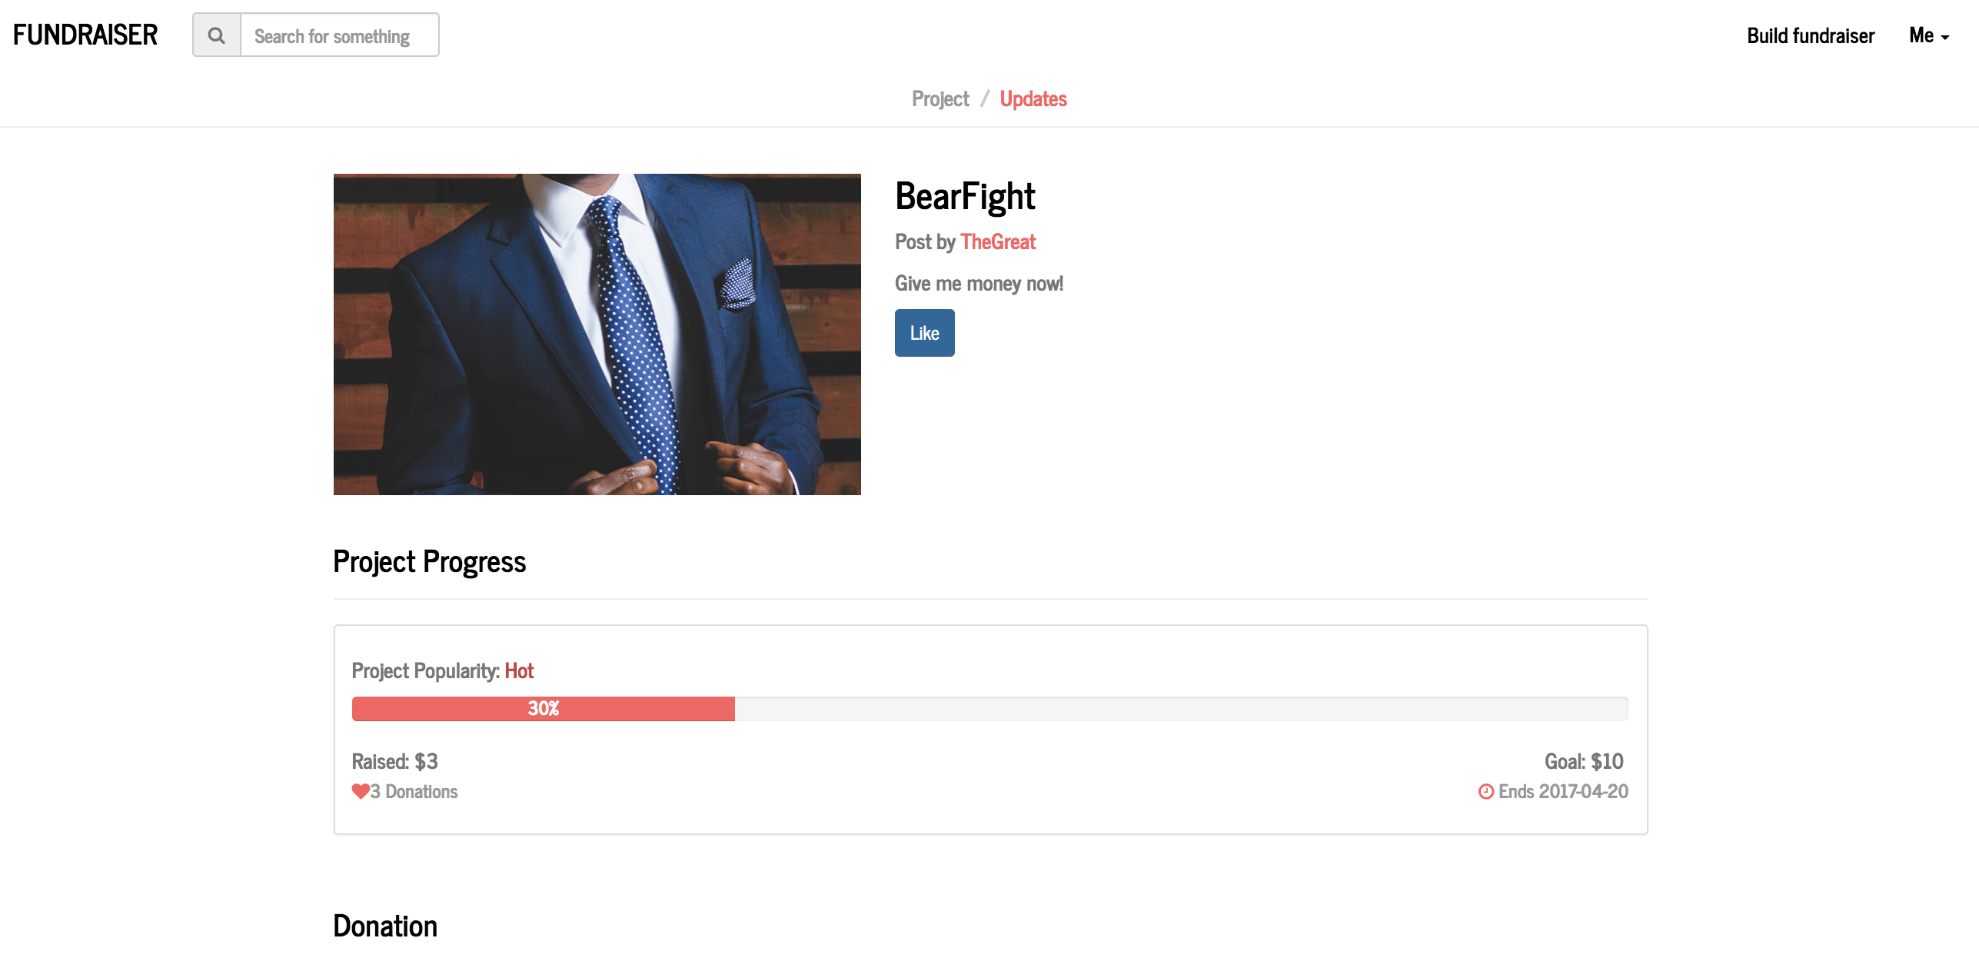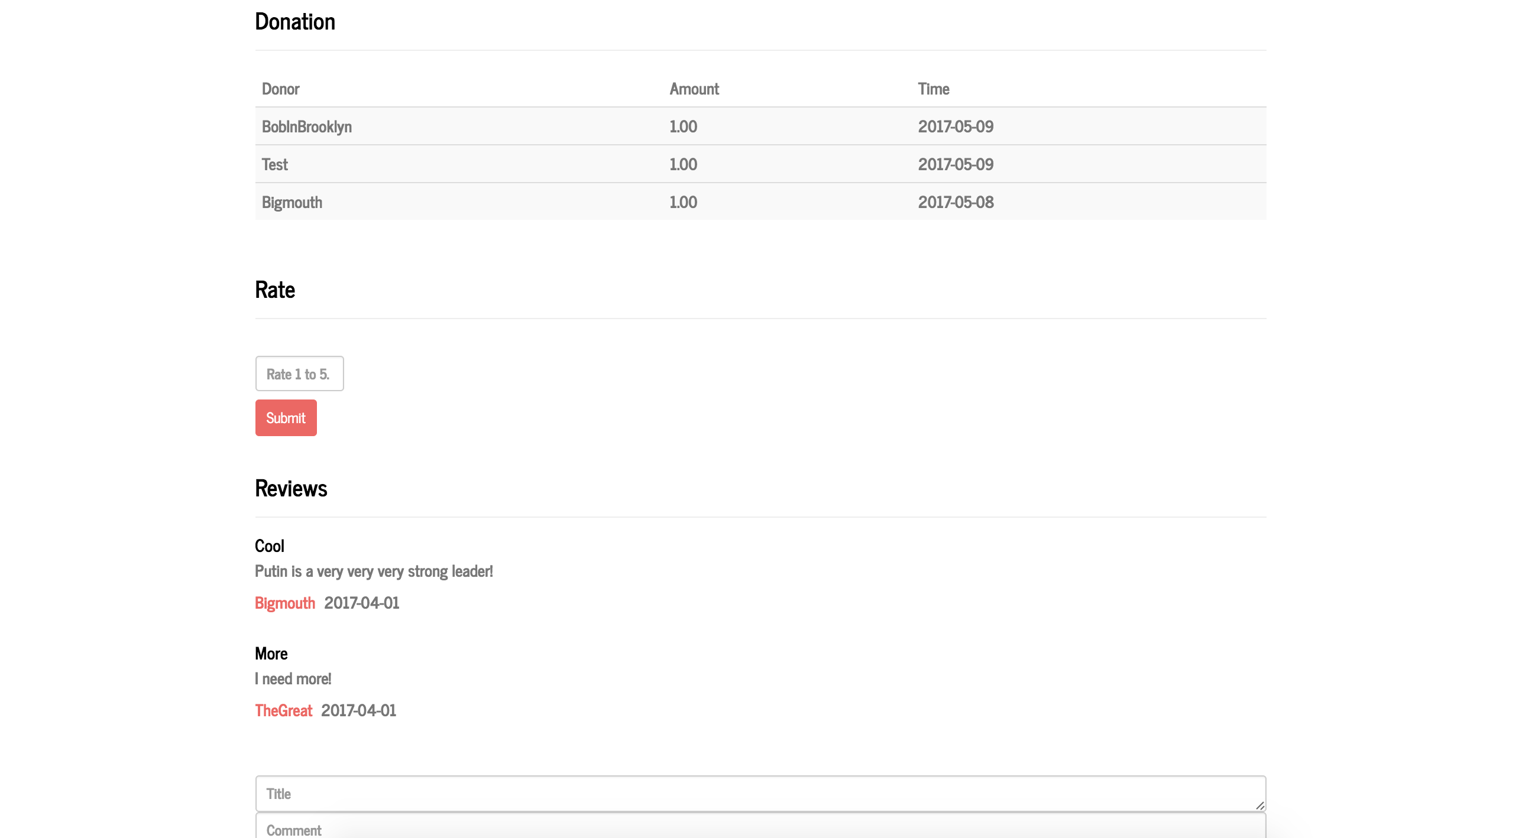

Since this project has successfully gotten minimum money and the time has expired, no donation option appears in this page. The user can figure out how much money the project has gotten and who donated to it. A ‘RATE’ option appears because the user I logged in is the one who donated before with username ‘BIGMOUTH’.

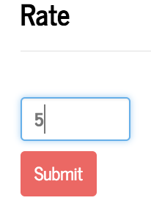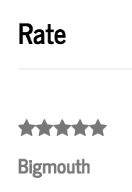

These two pictures show that I just rated a project with 5 stars.

At the bottom of the page, the user can see comments posted before and he/she can post a comment.

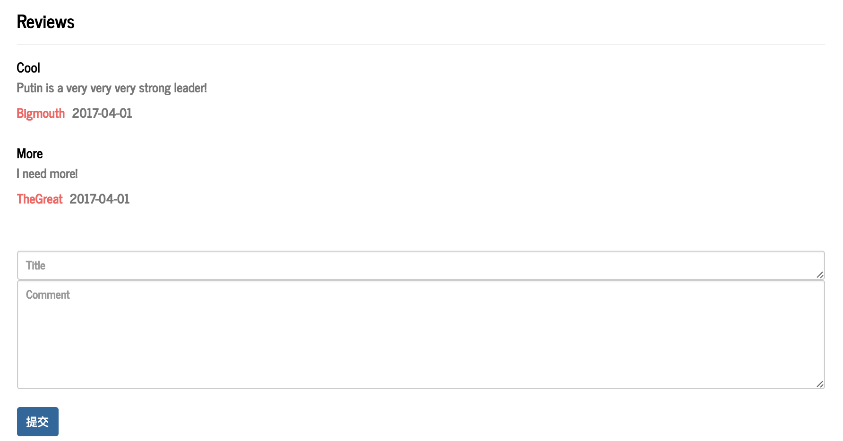

The user also can ‘like’ the project so he/she can get update information about this project at his/her personal page.

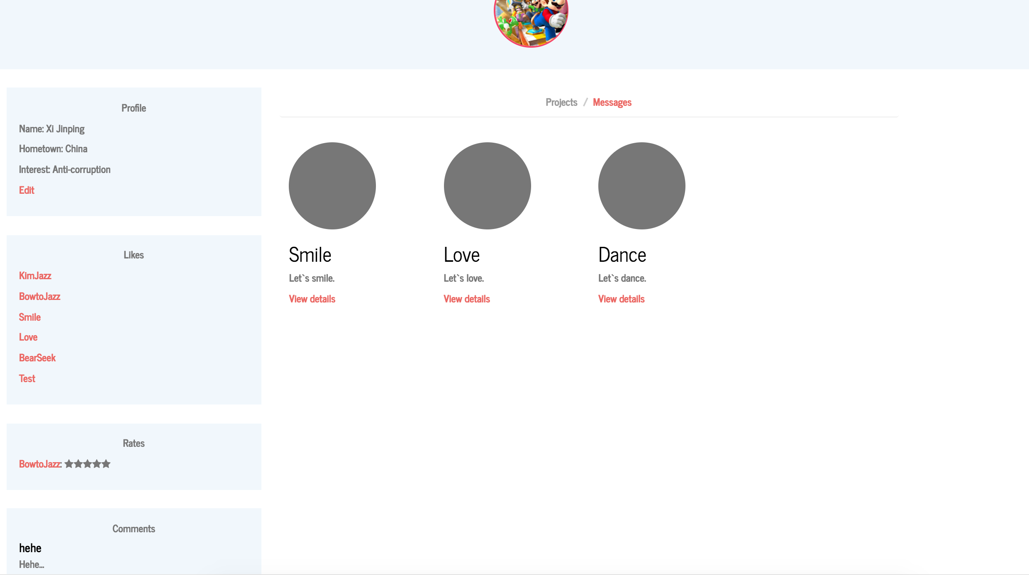

Here is the personal page of another user. From this page, the user can get to any projects he/she liked or posted or rated or commented. For example, he/she want to get to the project with the name ‘LOVE’.

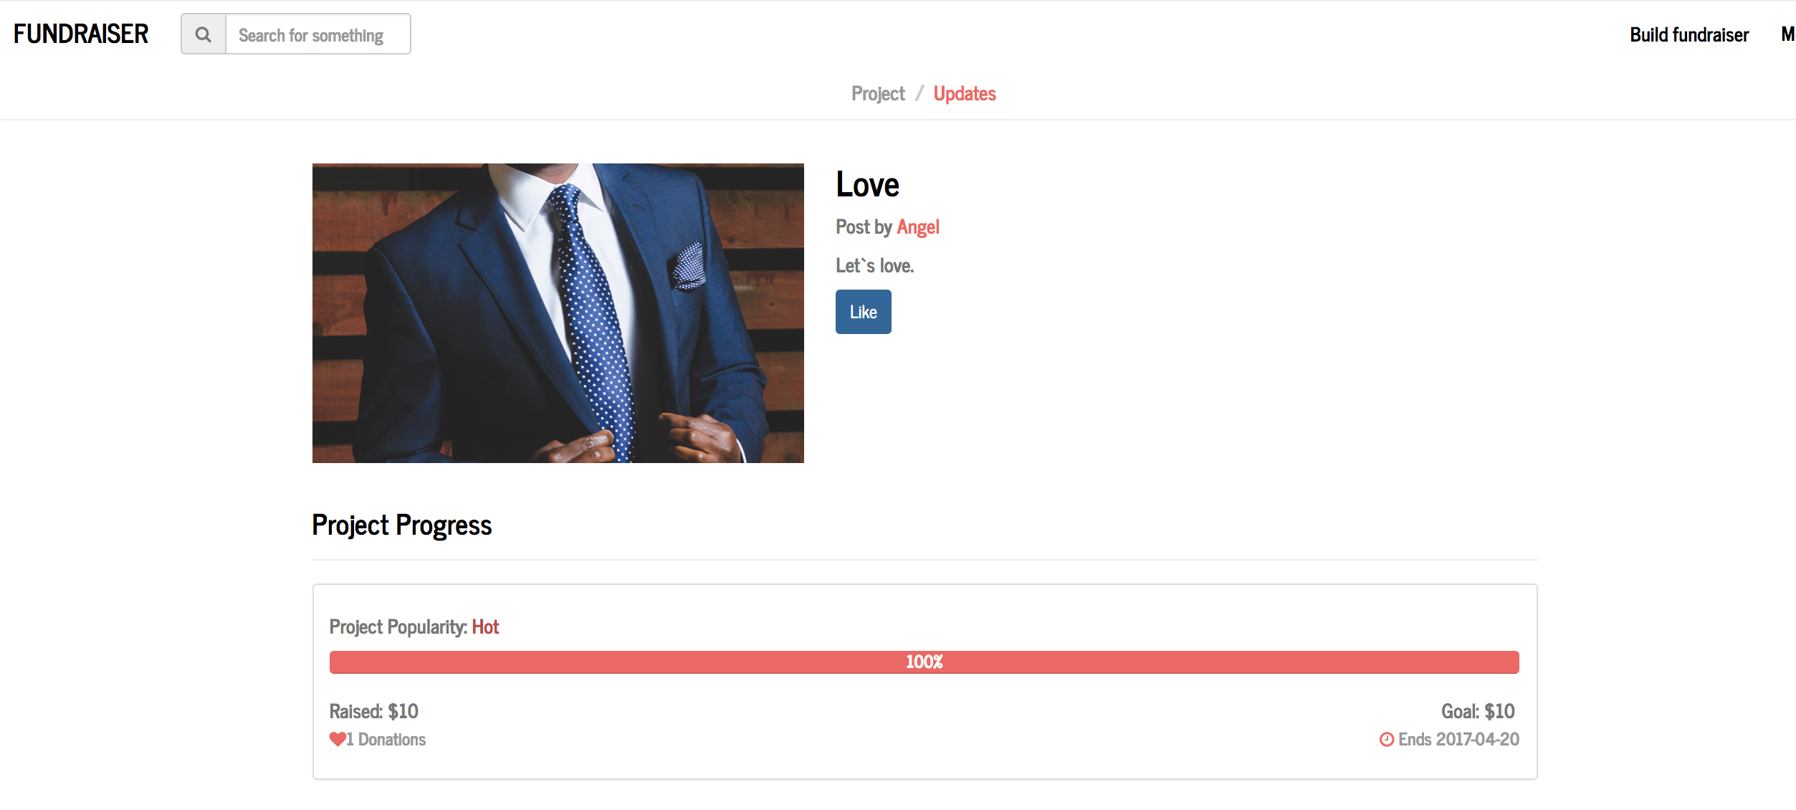

Now get back to personal page,

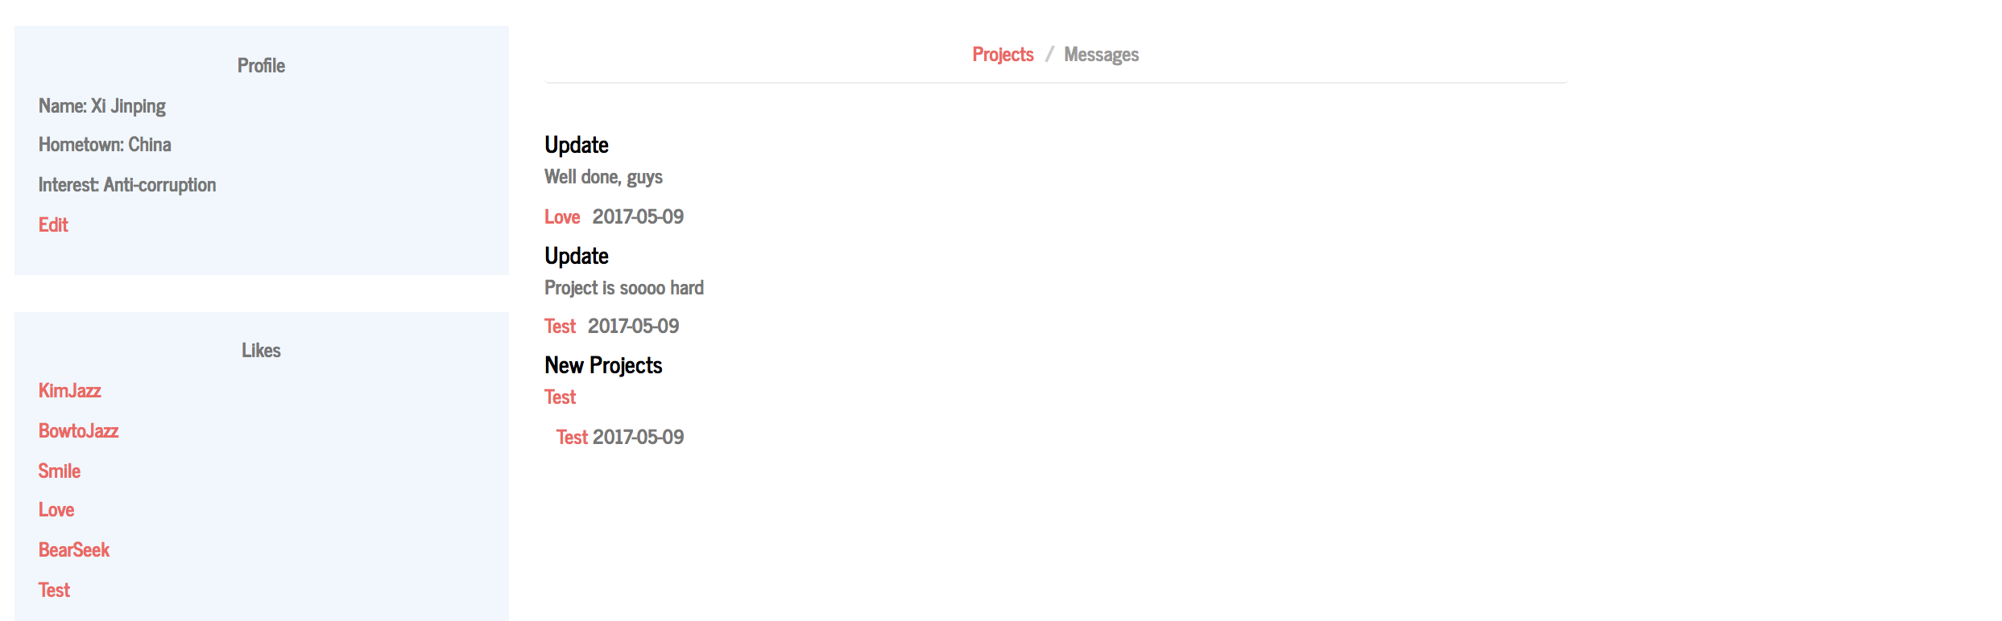

This page can also show messages about any one he/she followed and projects he/she liked. By clicking the name of another user, he/she can enter other’s personal page.

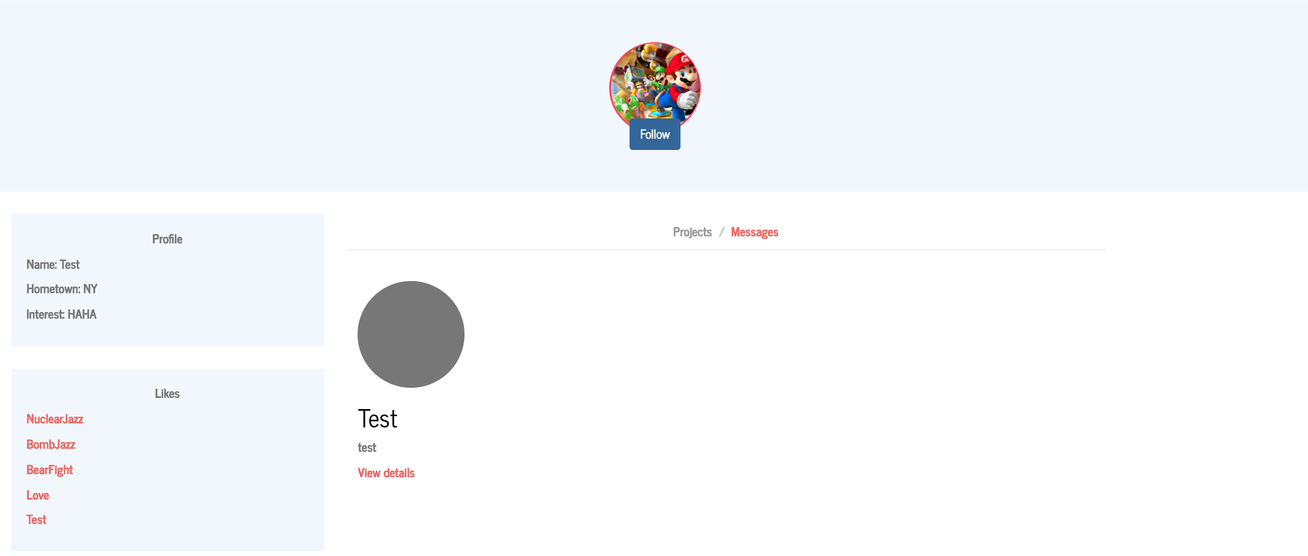

Like this one with name ‘TEST’, the user can see information about this user and follow this user.

When he/she decides to post a project, he/she can click “BUILD FUNDRAISER” at the nav-bar.

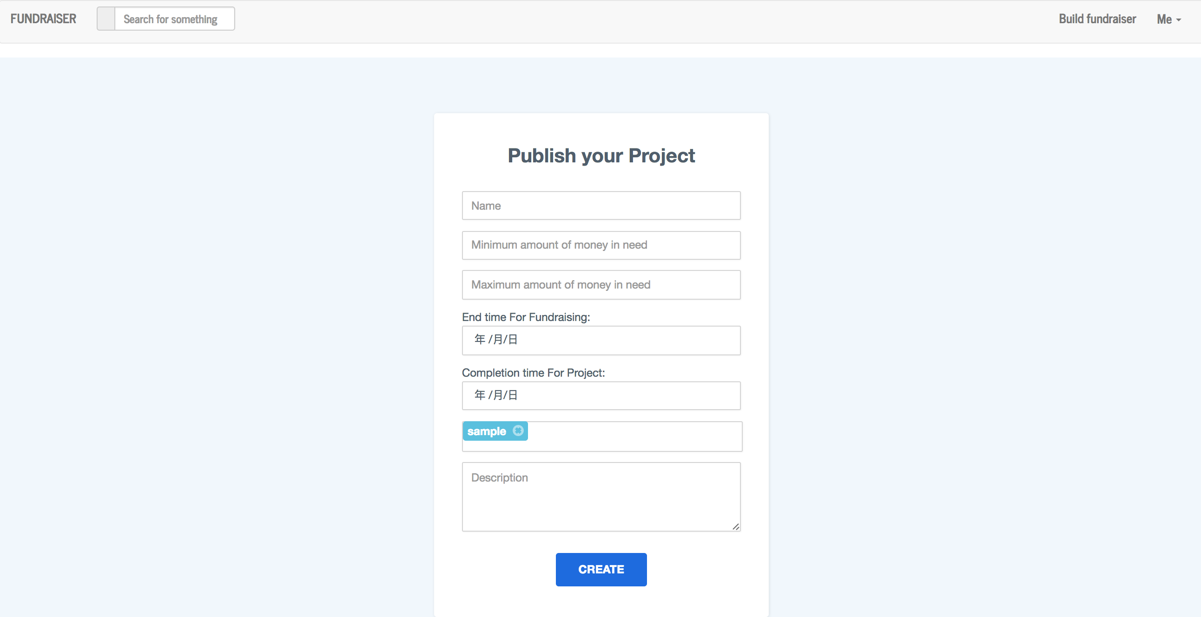

He/she needs to input some information about the project as the picture shows.

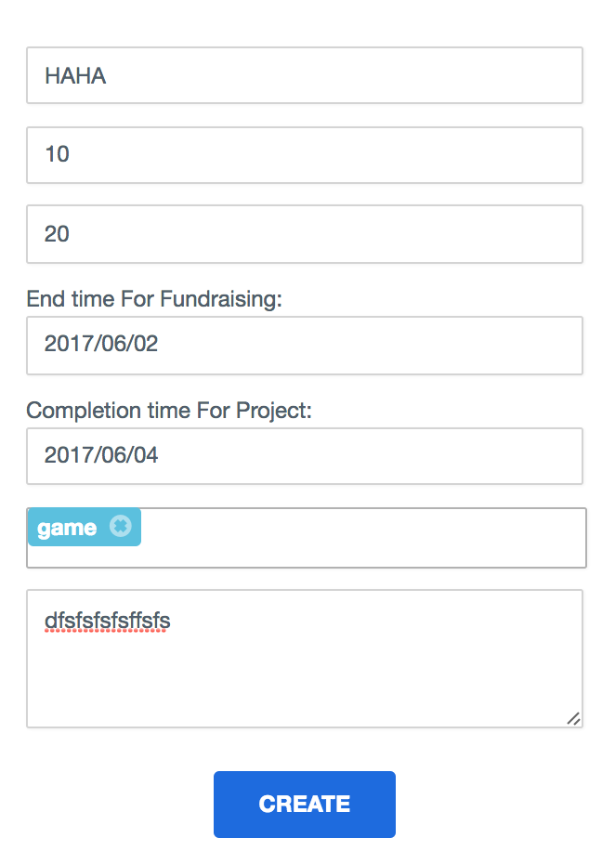

As the picture show, I just created a project with name ‘HAHA’ and tag ‘GAME’. After this, the user is redirected to the project page he/she just builds.

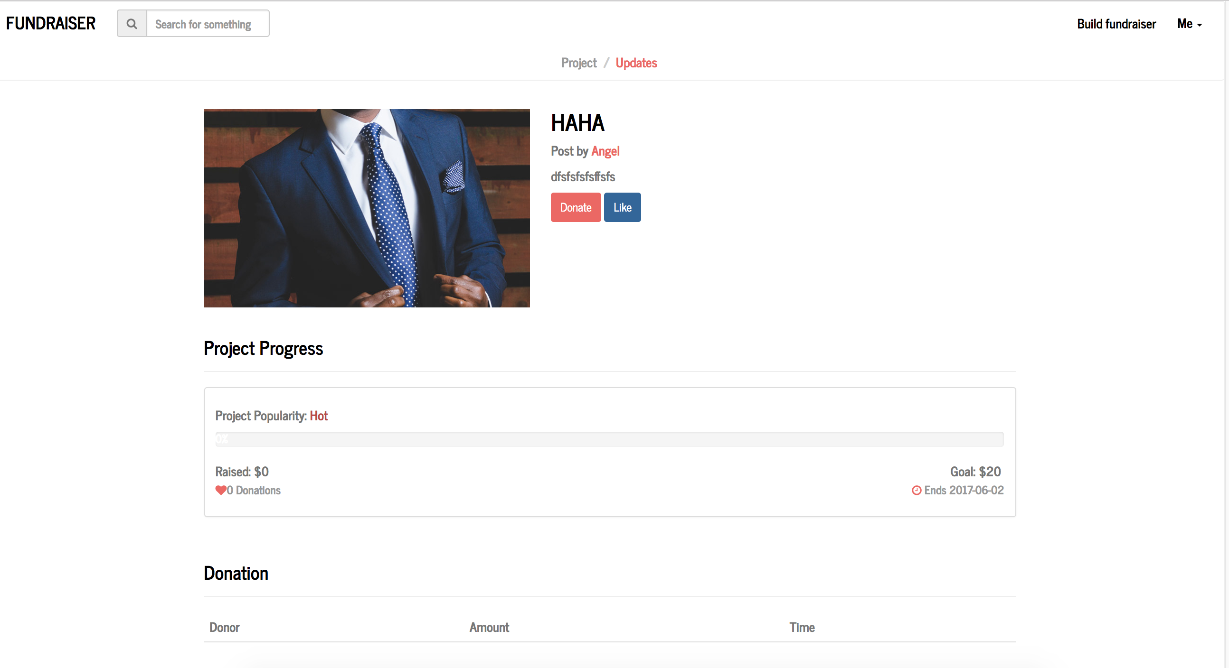

He/she can post updates like this:

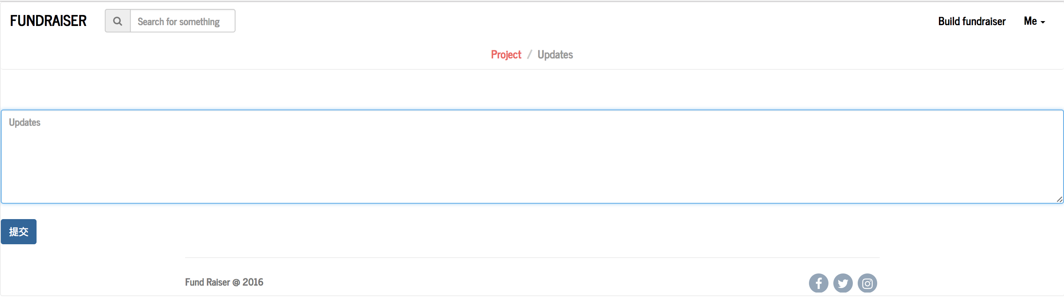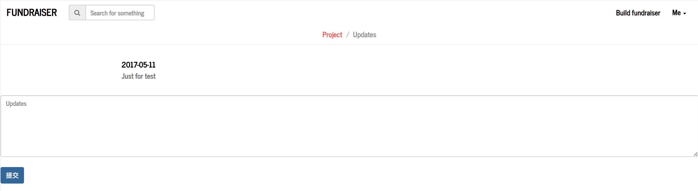

Or donate, like this:

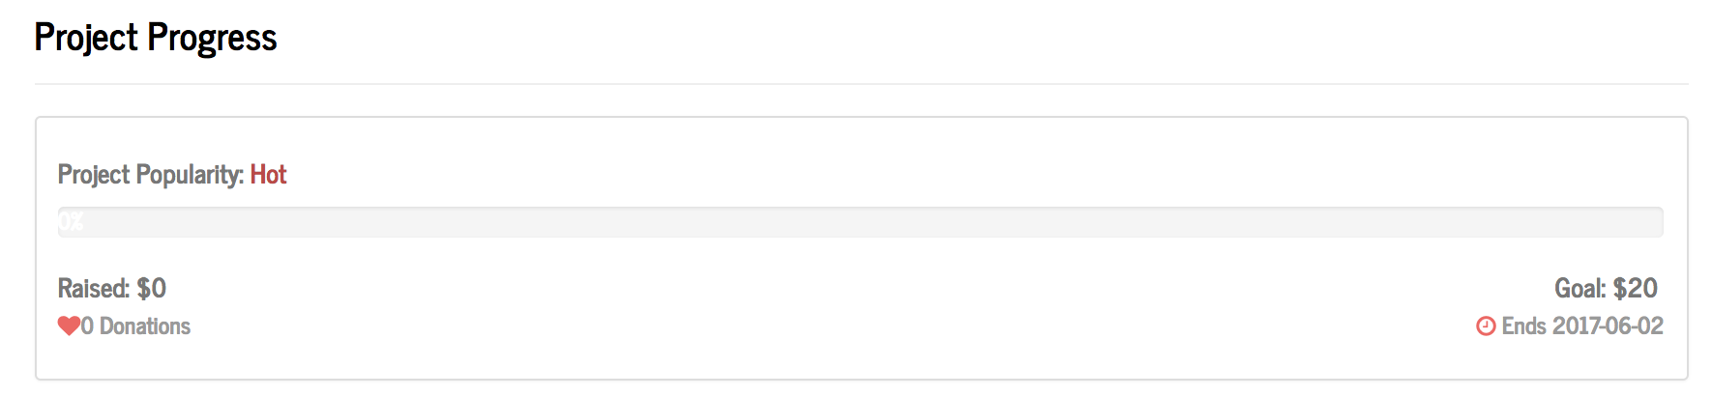

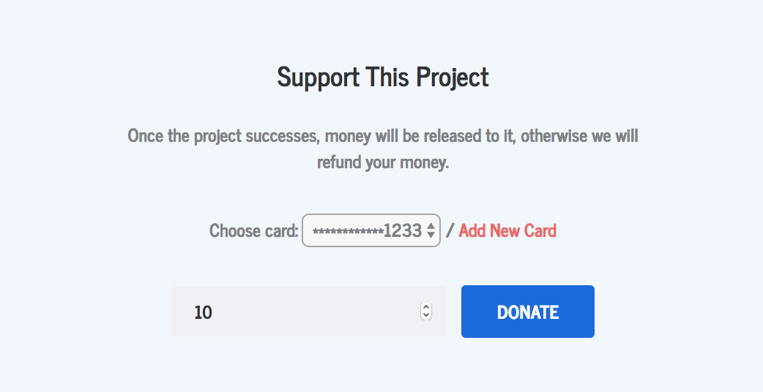

Or add a new card, like this:

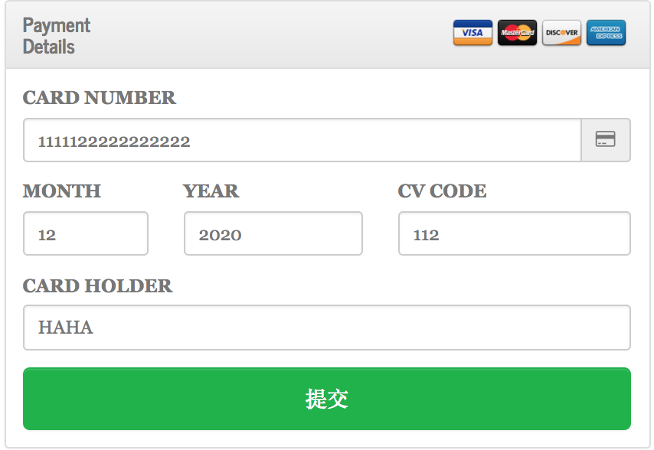

Finally, the donation is completed, like this:

